Project Design Phase-II
Data Flow Diagram & User Stories

Date | 03 Oct 2026
Team ID | Team 12
Project Name | Streamlining IT Procurement: Automating Standard Laptop Orders with Flow Designer
Maximum Marks | 4 Marks

Data Flow Diagrams:
A Data Flow Diagram (DFD) is a traditional visual representation of the information flows within a system. A neat and clear DFD can depict the right amount of the system requirement graphically. It shows how data enters and leaves the system, what changes the information, and where data is stored.

Example: (Simplified)

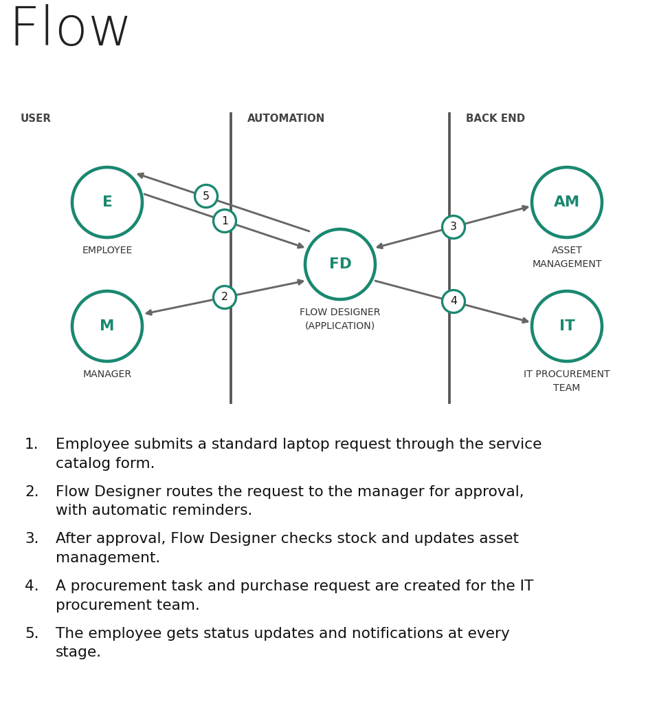

User Stories
Use the below template to list all the user stories for the product.
User Type | Functional Requirement (Epic) | User Story Number | User Story / Task | Acceptance criteria | Priority | Release
Employee (Applicant) | Laptop Request | USN-1 | As an employee, I can submit a standard laptop request by selecting a laptop model in the service catalog form. | A request number is generated and the request appears in My Requests | High | Sprint-1
 |  | USN-2 | As an employee, I can have my name, department and location filled in automatically from my profile so that I do not re-enter details. | Form is pre-filled and mandatory fields are validated before submitting | High | Sprint-1
 |  | USN-3 | As an employee, I will receive a confirmation email once I have submitted my laptop request. | I can receive the confirmation email with my request number | Medium | Sprint-1
 |  | USN-4 | As an employee, I can view the approved standard laptop models with their specifications before ordering. | Only approved standard models and specs are listed | Medium | Sprint-1
 | Order Tracking | USN-5 | As an employee, I can track the status of my laptop order (approval, procurement, shipping, delivery). | I can see the current status without raising a support ticket | High | Sprint-2
 | Notifications | USN-6 | As an employee, I will receive a notification whenever my request status changes. | Email or portal notification is received at every stage | Medium | Sprint-2
Manager (Approver) | Approval | USN-7 | As a manager, I will automatically receive an approval request for my team member's laptop request. | Approval task with full request details reaches me and I can approve or reject it | High | Sprint-1
IT Procurement Staff | Procurement | USN-8 | As an IT staff member, I can get a procurement task created automatically with the laptop specs and user details. | Task details match the request with no manual copy-paste | High | Sprint-2
Administrator | Inventory Sync | USN-9 | As an administrator, I can sync approved orders with asset management so that stock is checked before ordering. | Stock is checked, duplicate purchases are avoided and an asset record is created on delivery | High | Sprint-3
Manager (Approver) | Approval | USN-10 | As a manager, I will receive automatic reminders, and the request is escalated if I do not respond in time. | Reminder is sent at set intervals and escalated to the next approver after 48 hours | Medium | Sprint-2
IT Procurement Staff | Procurement | USN-11 | As an IT staff member, I can have a purchase request sent to the vendor automatically for approved laptops that are out of stock. | Purchase request is created and linked to the original request | Medium | Sprint-2
Administrator | Reporting | USN-12 | As an administrator, I can view a dashboard of pending, approved and delivered laptop requests. | Dashboard shows request counts by status | Low | Sprint-3

